**– Penamaan Variabel –**

* btn_tampilkanreport
* btn_eksportpdf
* btn_eksportexcel

**– Codingan Imports & Dim & btn_tampilkanreport –**

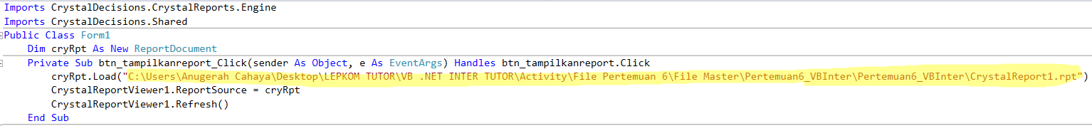

**– Codingan btn_eksportpdf –**

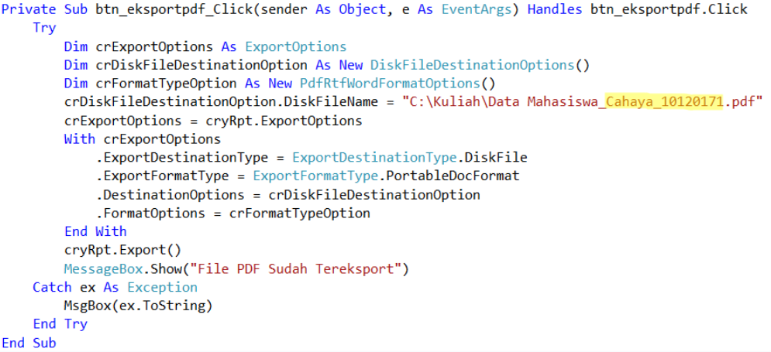

**– Codingan btn_eksportexcel –**

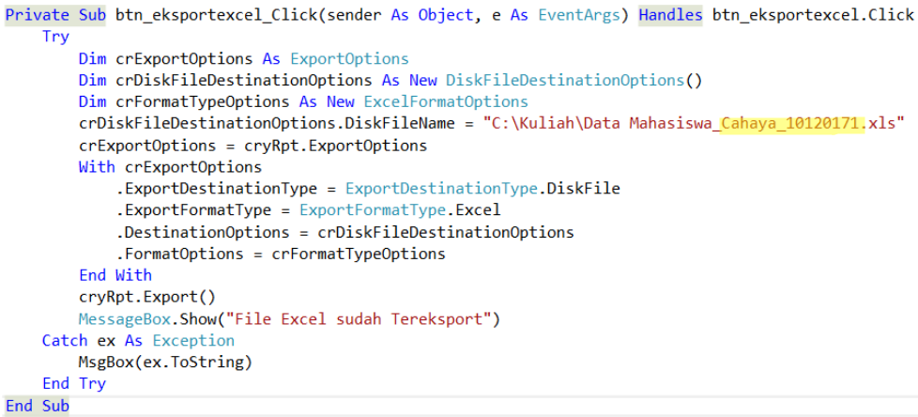

**– Screenshot –**

* Codingan setiap button
* Tampilkan Report
* Eksport PDF
* Eksport Excel
* File Explorer